**Раздел 1**

1.1 - <https://github.com/Igor-voy/2sem-practice/blob/master/%D0%97%D0%B0%D0%B4%D0%B0%D0%BD%D0%B8%D0%B5%201.1.pdf>

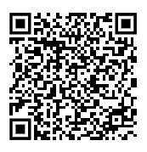

1.2 - <https://github.com/Igor-voy/2sem-practice/blob/master/%D0%97%D0%B0%D0%B4%D0%B0%D0%BD%D0%B8%D0%B5%201.2.pdf>



1.3

1.4

1.5

1.6

1.7

1.8

1.9

1.10

1.11

**Раздел 2**